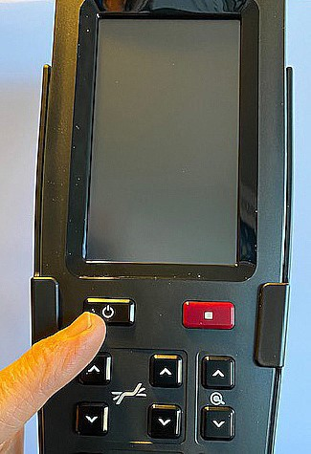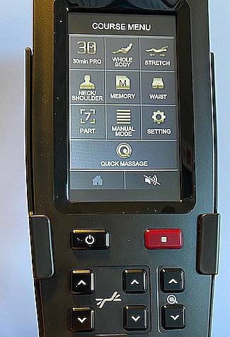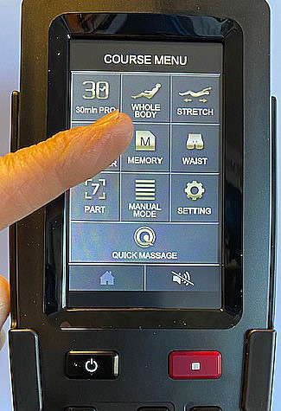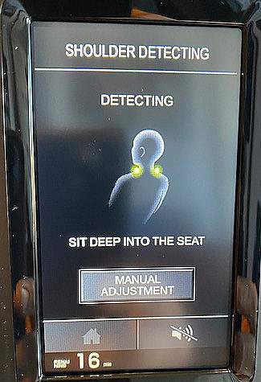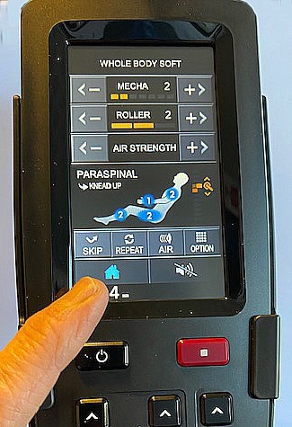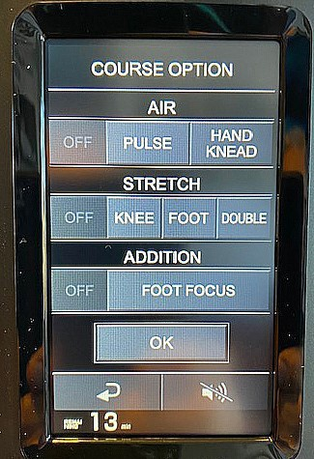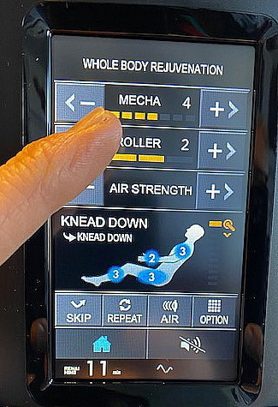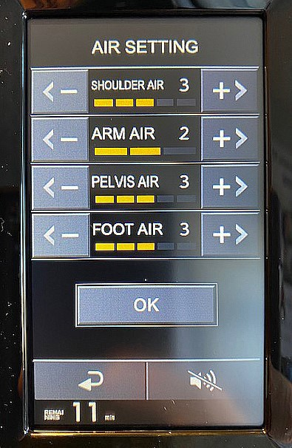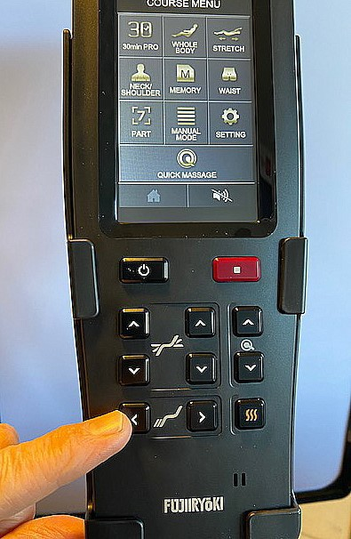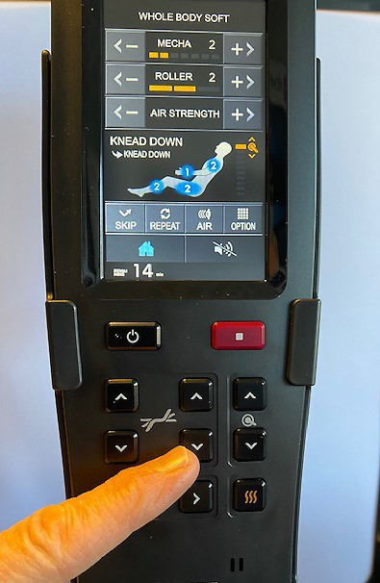



QUICK-START FUJICYBERRELAX JP-2000

**1** Take oﬀ your shoes

Let footstool rise

completely. Then adjust the length of your legs with arrow left.

**2**

Sit with your back deep into

the chair. Then press the black on / oﬀ button.

Turn on the heat.

Starting Whole-body

massage.

At the neck scan can

you also adjust manually. Then press

MANUAL ADJUSTMENT

**3a**

**3b**

*For better neck mas-*

*sage Remove the headrest .*

If you are over 185 cm

tall, of knee stretch. Press OPTION followed by KNEE, OFF, finish with OK.

**OBS: If you are tall**

If needed, or if you are long,

adjustable tilt backwards on the chair with the arrow down.

*Knee strech is now off*

**Choose between**

**Whole Body Shoulder Waist or stretch.**

**In the stretch tilting**

**backrest down.**

For a change

press house buttom

of

or

program,

the

red

Hardness Adjustments

*Regulate the*

*hardness of back massage MECHA*

*+ or -*

Regulate

hardness shoulders, arms, pelvis and feet

Friskonomen AB

[www.friskonomen.se](http://www.friskonomen.se/)

031-352 93 80